|  |  |  |
| --- | --- | --- |
| ΑΤΙ | Tech It Easy | Access Technologies, Inc.  February 2019 Edition  Editor: Laurie Brooks |

|  |  |
| --- | --- |
| **Inside this Issue:** | |
| Eyewear | 1 |
| Handheld Magnification | 2 |
| ATM - MarketPlace | 3 - 7 |
| Bargain Basement | 8 - 9 |
| Telescopes | 10 |
| Future of Low Vision Aids | 10 - 11 |
| iCanConnect-Oregon | 12 |

## Experiencing Vision Loss? – You are Not Alone!

With people in the United States living longer, eye diseases and vision loss have become major public health concerns. According to the National Eye Institute, approximately 4.2 million Americans age 40 and older experience some degree of vision loss, and that number is expected to reach 5 million by 2030.

While age-related macular degeneration, cataracts, diabetic retinopathy, and glaucoma are the leading causes of vision loss, there is good news. The ongoing development of low vision optical devices, or assistive technology (AT) helps people maintain or regain their visual independence! Many low vision AT devices are task-specific, so it’s common for people to use several different ones throughout their day. Here’s a quick look at some popular low vision AT devices.



**The Mysterious Function of Eyelashes**

Most mammal’s eyelashes are one-third the length of their eyes.

Eyelashes minimize the flow of air over the eyeballs;

keeping evaporation at bay and

preventing irritating dust from getting deposited on the surface of our eyes.

## Eyewear

Eyeglasses have come a long way since the original “glass lens for reading” were created in 1301. Today, most people will choose single strength eyewear when they need a little “help” for a specific task such as reading. But when you require glasses for multiple tasks be sure to talk with your eye care physician about the appropriate multifocal lens for you – bifocal, trifocal or progressive, which as the name implies, gradually changes in power from the top half of the lens to the bottom, and therefore contain many lens powers.

When you work on a computer or smartphone, watch TV or go out in the sun, your eyes are exposed to **h**igh-**e**nergy **v**isible (HEV) blue light. During the daytime, natural blue light from the sun helps keep us awake and regulates our “body clock”, and while indoors, blue light is emitted from digital devices, as well as artificial light sources such as LED and fluorescent lights. Over time, too much blue light exposure can damage eyes. Blue block eyewear, such as the 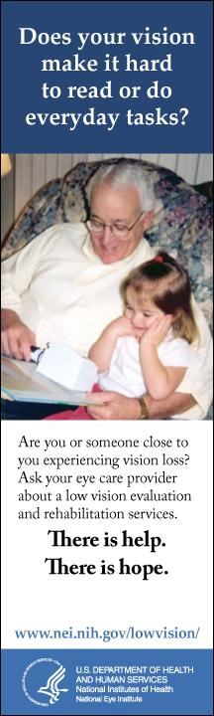Polinelli collection designed for everyday tasks including reading and computer usage, block approximately 30% of the *harmful* blue light and also feature UVA/UVB protection; eliminating glare and therefore providing enhanced visual clarity.

Curious about Blue Light Blocking eyewear? ATI has the Polinelli collection in strengths from 0.0 to 4.0 on hand.

While eyewear may accommodate many of our daily tasks, we may find some spot reading tasks such as selecting the settings on the washer or dryer, adjusting the thermostat, or reading the package ingredients while at the store a little challenging. That’s when handheld magnification might be considered.

## Handheld Magnification

Handheld magnifiers have come a long way since the invention of the magnifying glass in 1250, and since they are not all created equally, selecting the right one can be a little challenging. Therefore, identifying the best visual aid for your spot reading tasks requires more than just selecting the appropriate magnification strength. For example, did you know quality lens are manufactured to ensure the lens do not shrink or change shape during the manufacturing process? This allows for edge-to-edge distortion-free viewing; providing a larger field of view, so you can see more letters at a time. Illuminated magnifiers allow you the option to use a little extra light when and where necessary, like in a dark restaurant, but when exploring this option, make sure the magnifier provides consistent, non-glaring lighting. For longer term viewing tasks head worn telescopes might be considered.

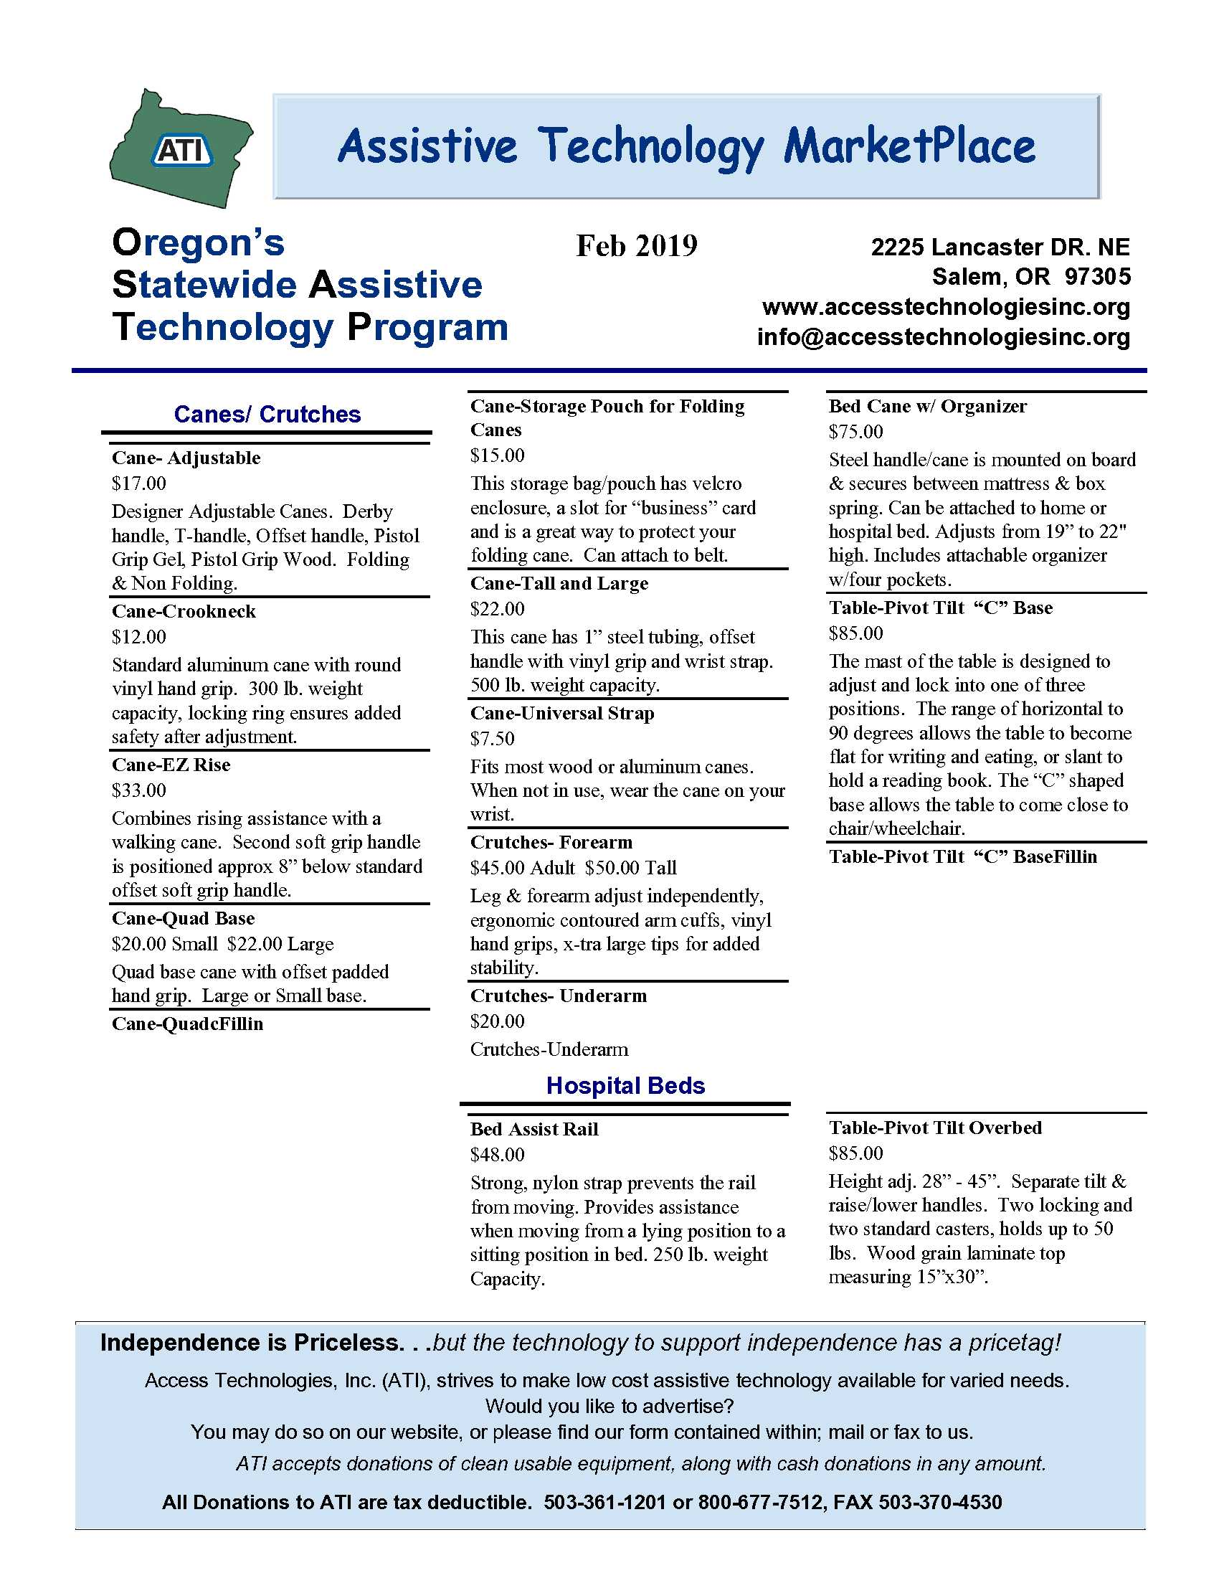footerbar

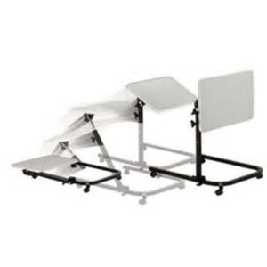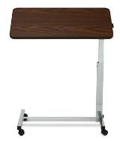

**Overbed Table Pivot Top**

**Overbed Table Pivot Tilt – C Base**

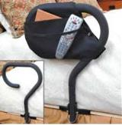

**Bed Cane**

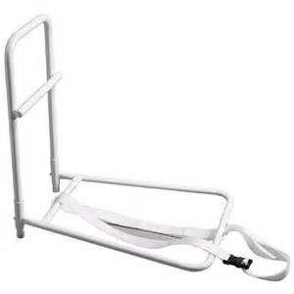

**Bed Assist Rail**

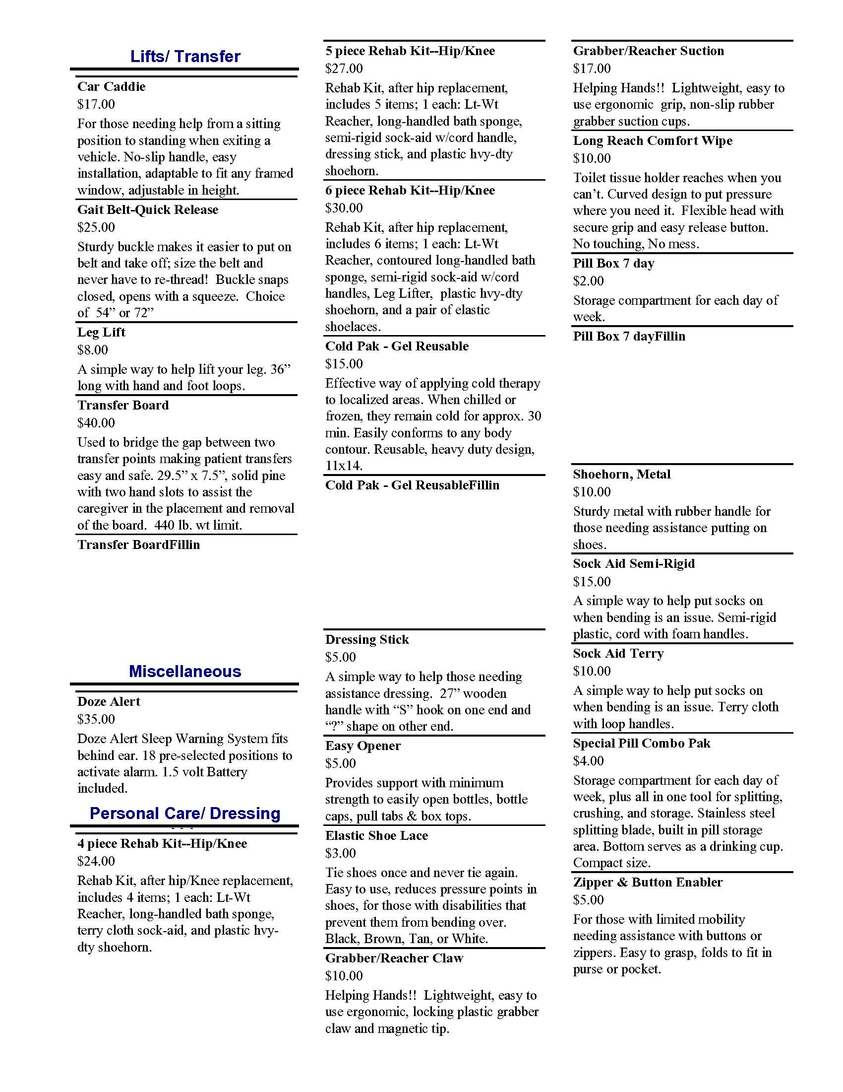

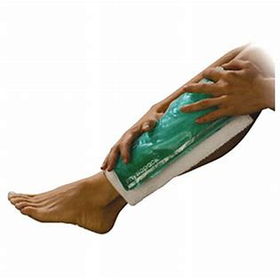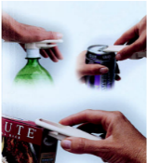

**Gel Cold Pak**

**Enabler Easy Opener**

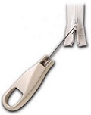

**Button/Zipper Pull**

**Leg Lifter**

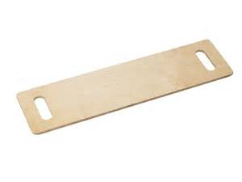

**Transfer Board**

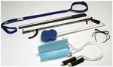

**Six Piece Rehab Kit**

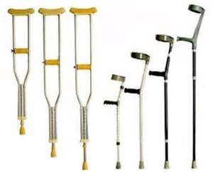

**Crutches**



**Six Piece Rehab Kit**

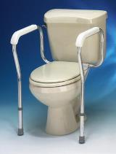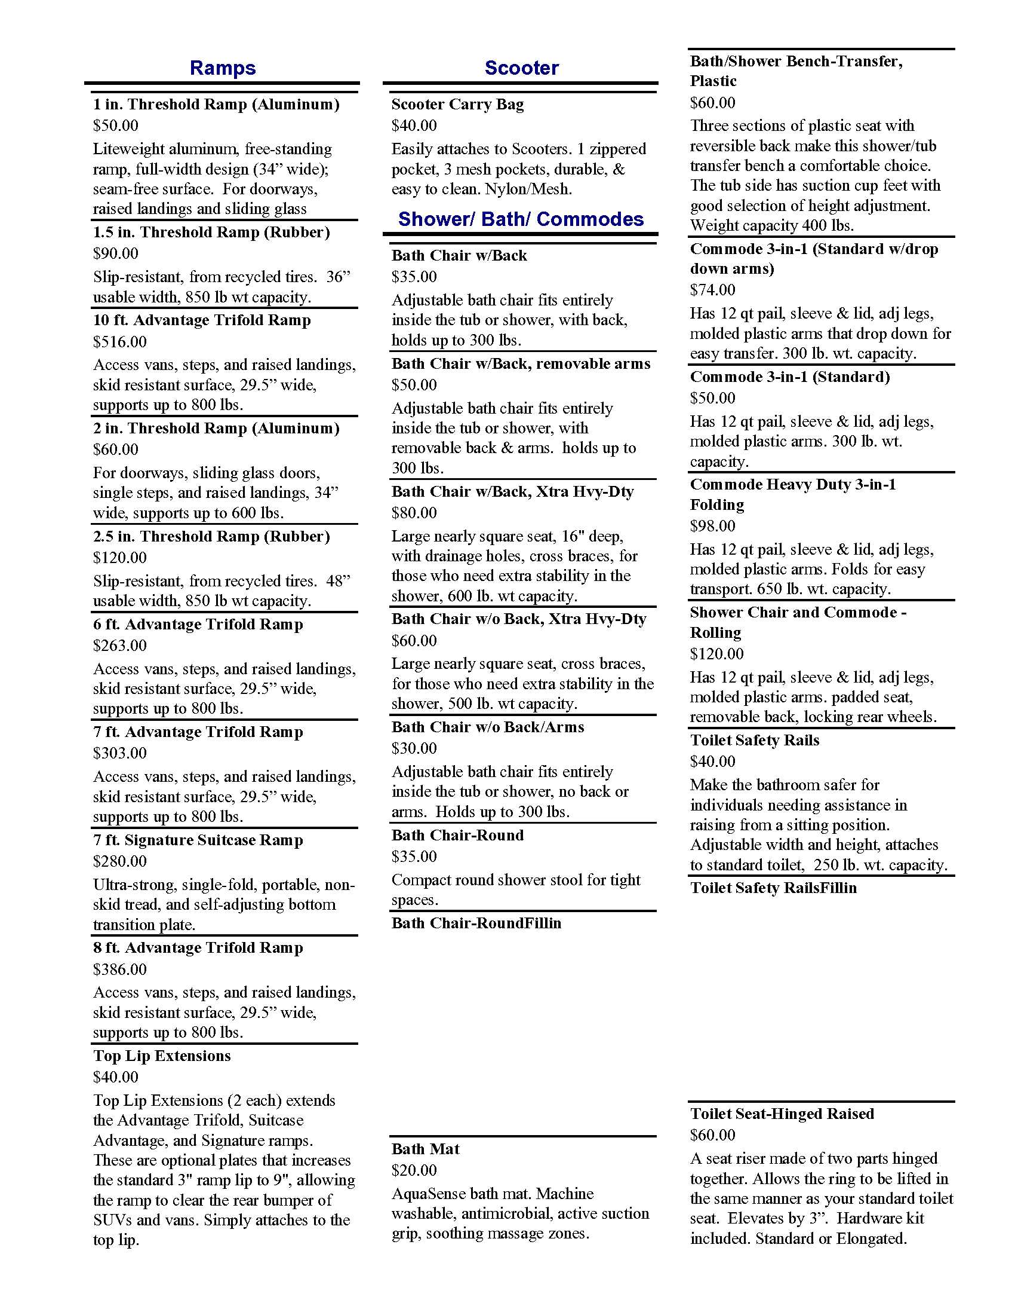

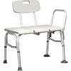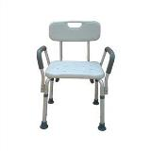

**Bath Transfer Bench**

**Bath Chair**

**Toilet Safety Rails**

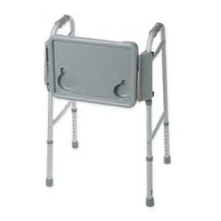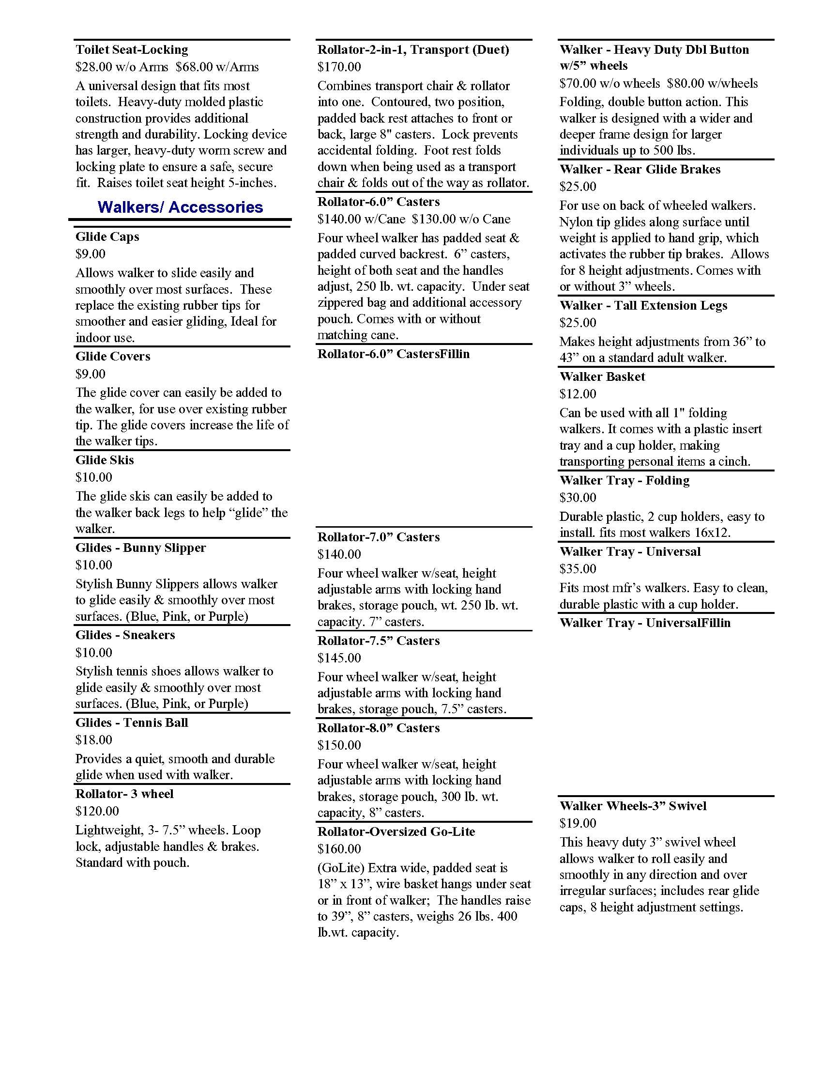

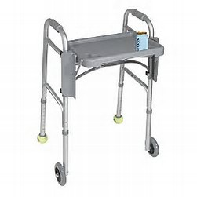

**Universal Walker Tray**

**Folding Walker Tray**

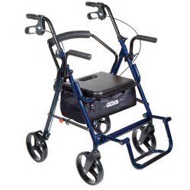

**Duet**

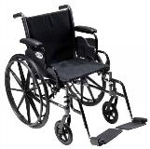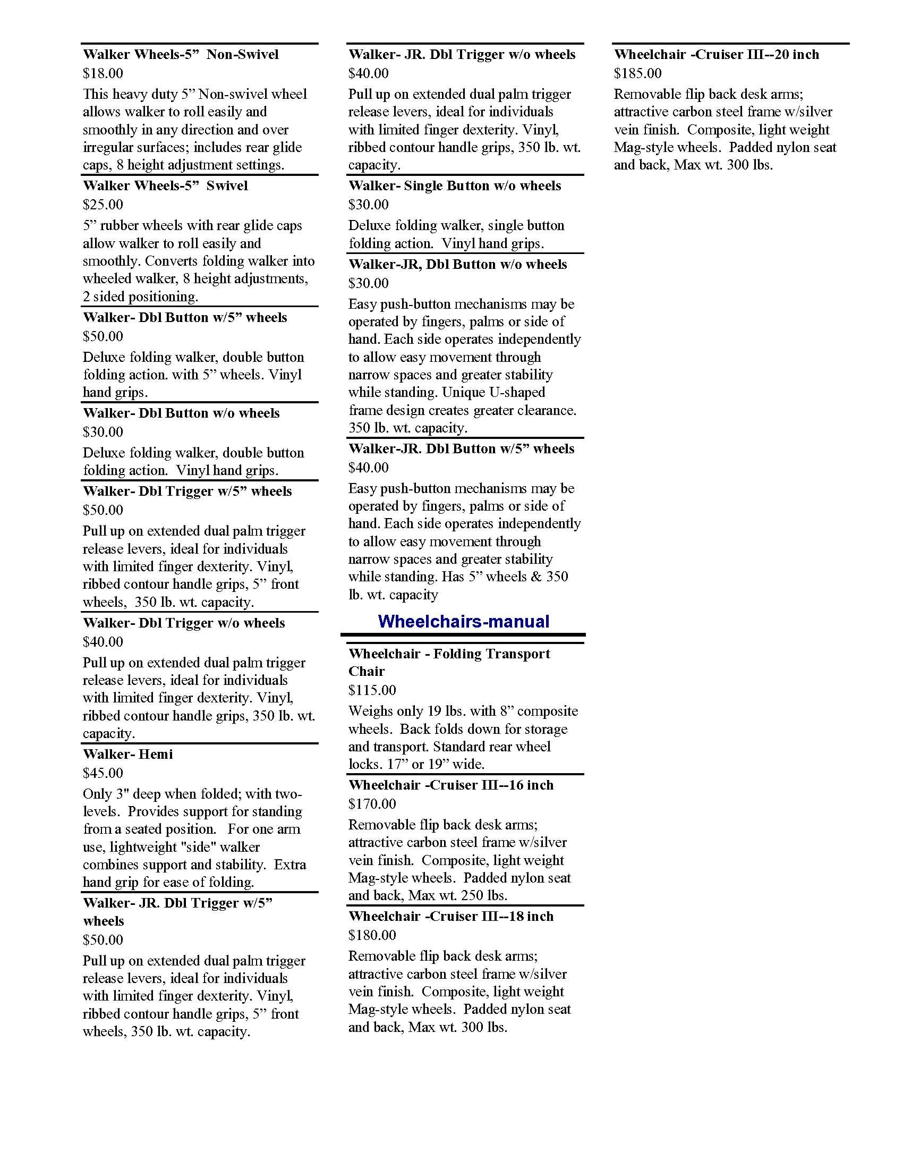

**Glides**

**Bunny Slippers**

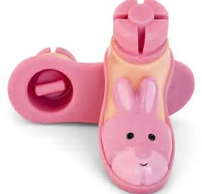

**Cruiser III Manual Wheelchair**

**Glide Skis**

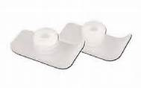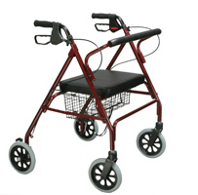

**GoLite Rollator**

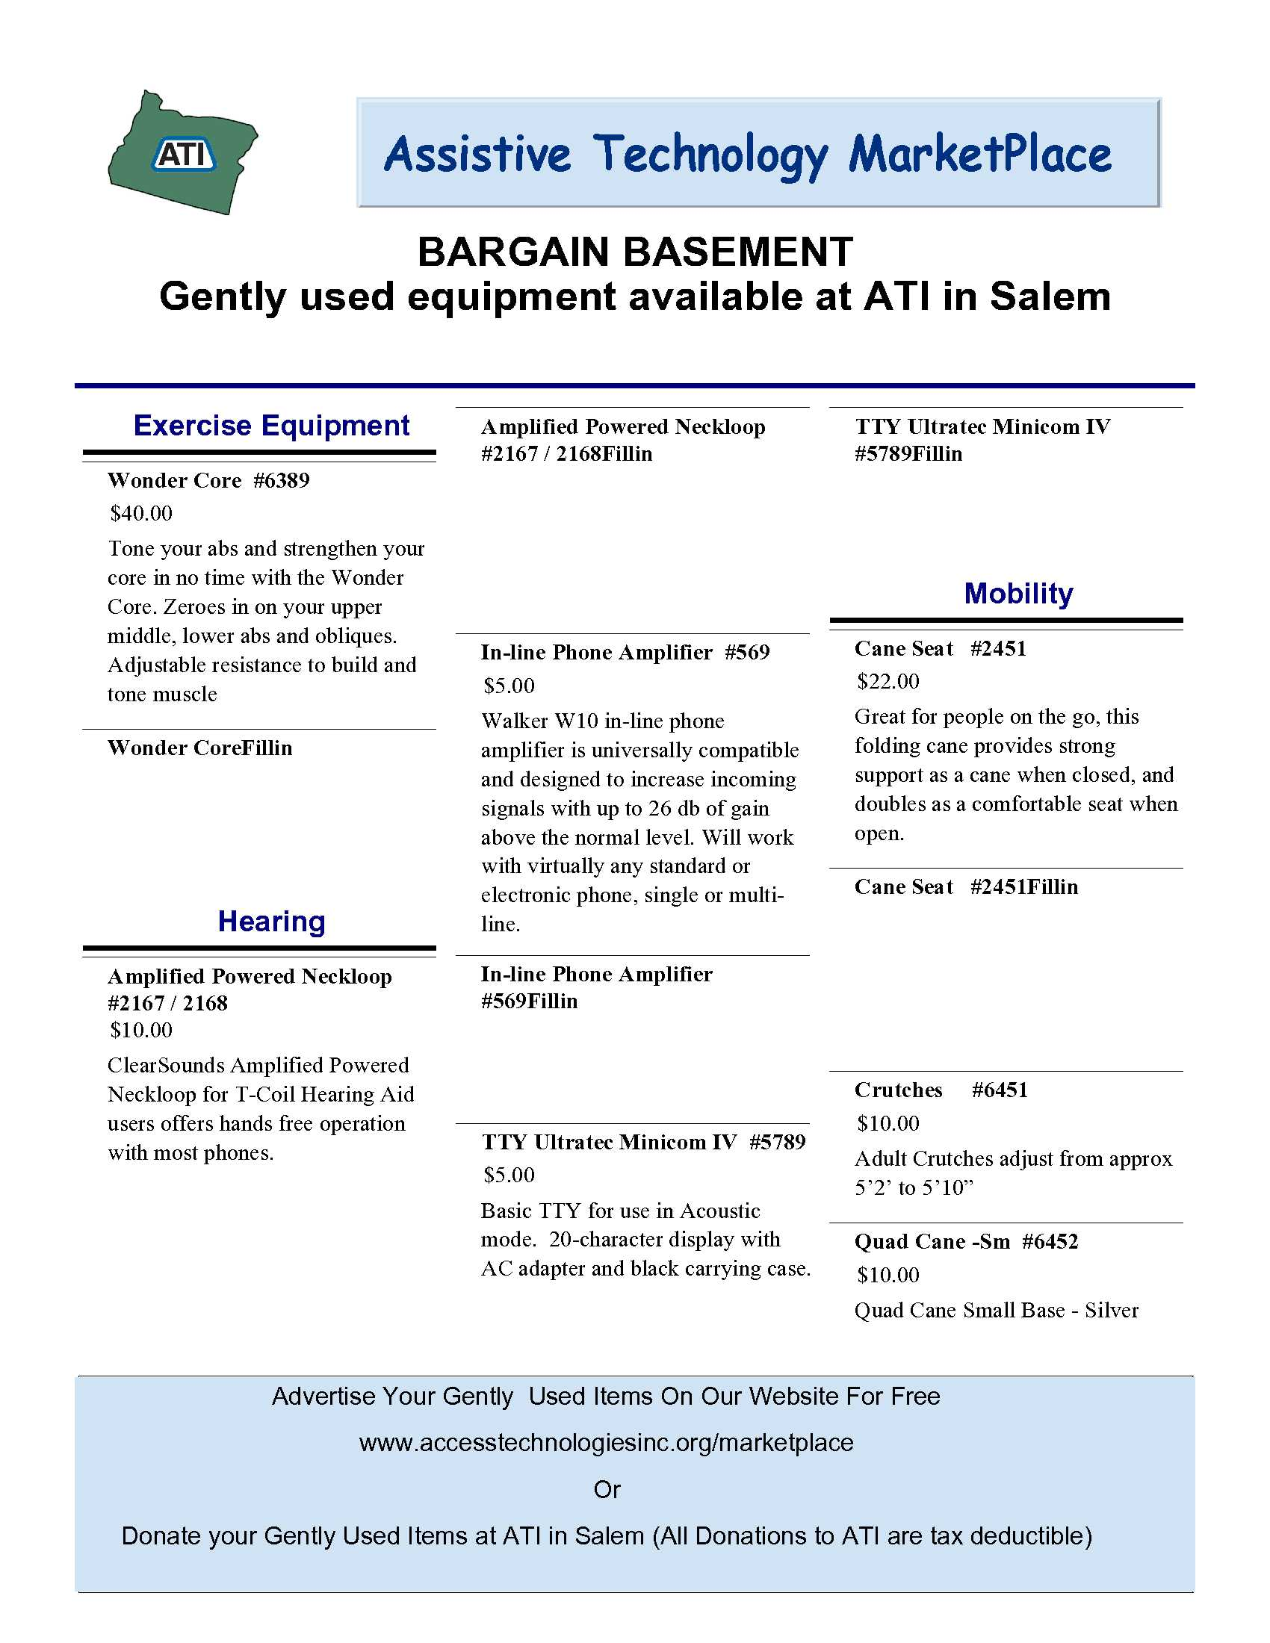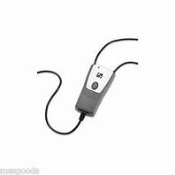

**Amplified Neckloop**

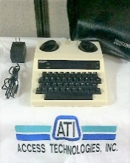

**TTY**



**Wonder Core**

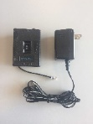

**In-Line Phone Amplifier**

**Cane Seat**

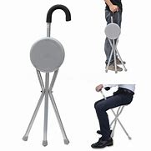

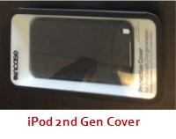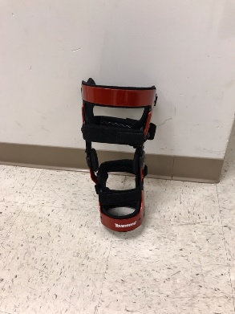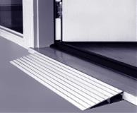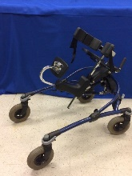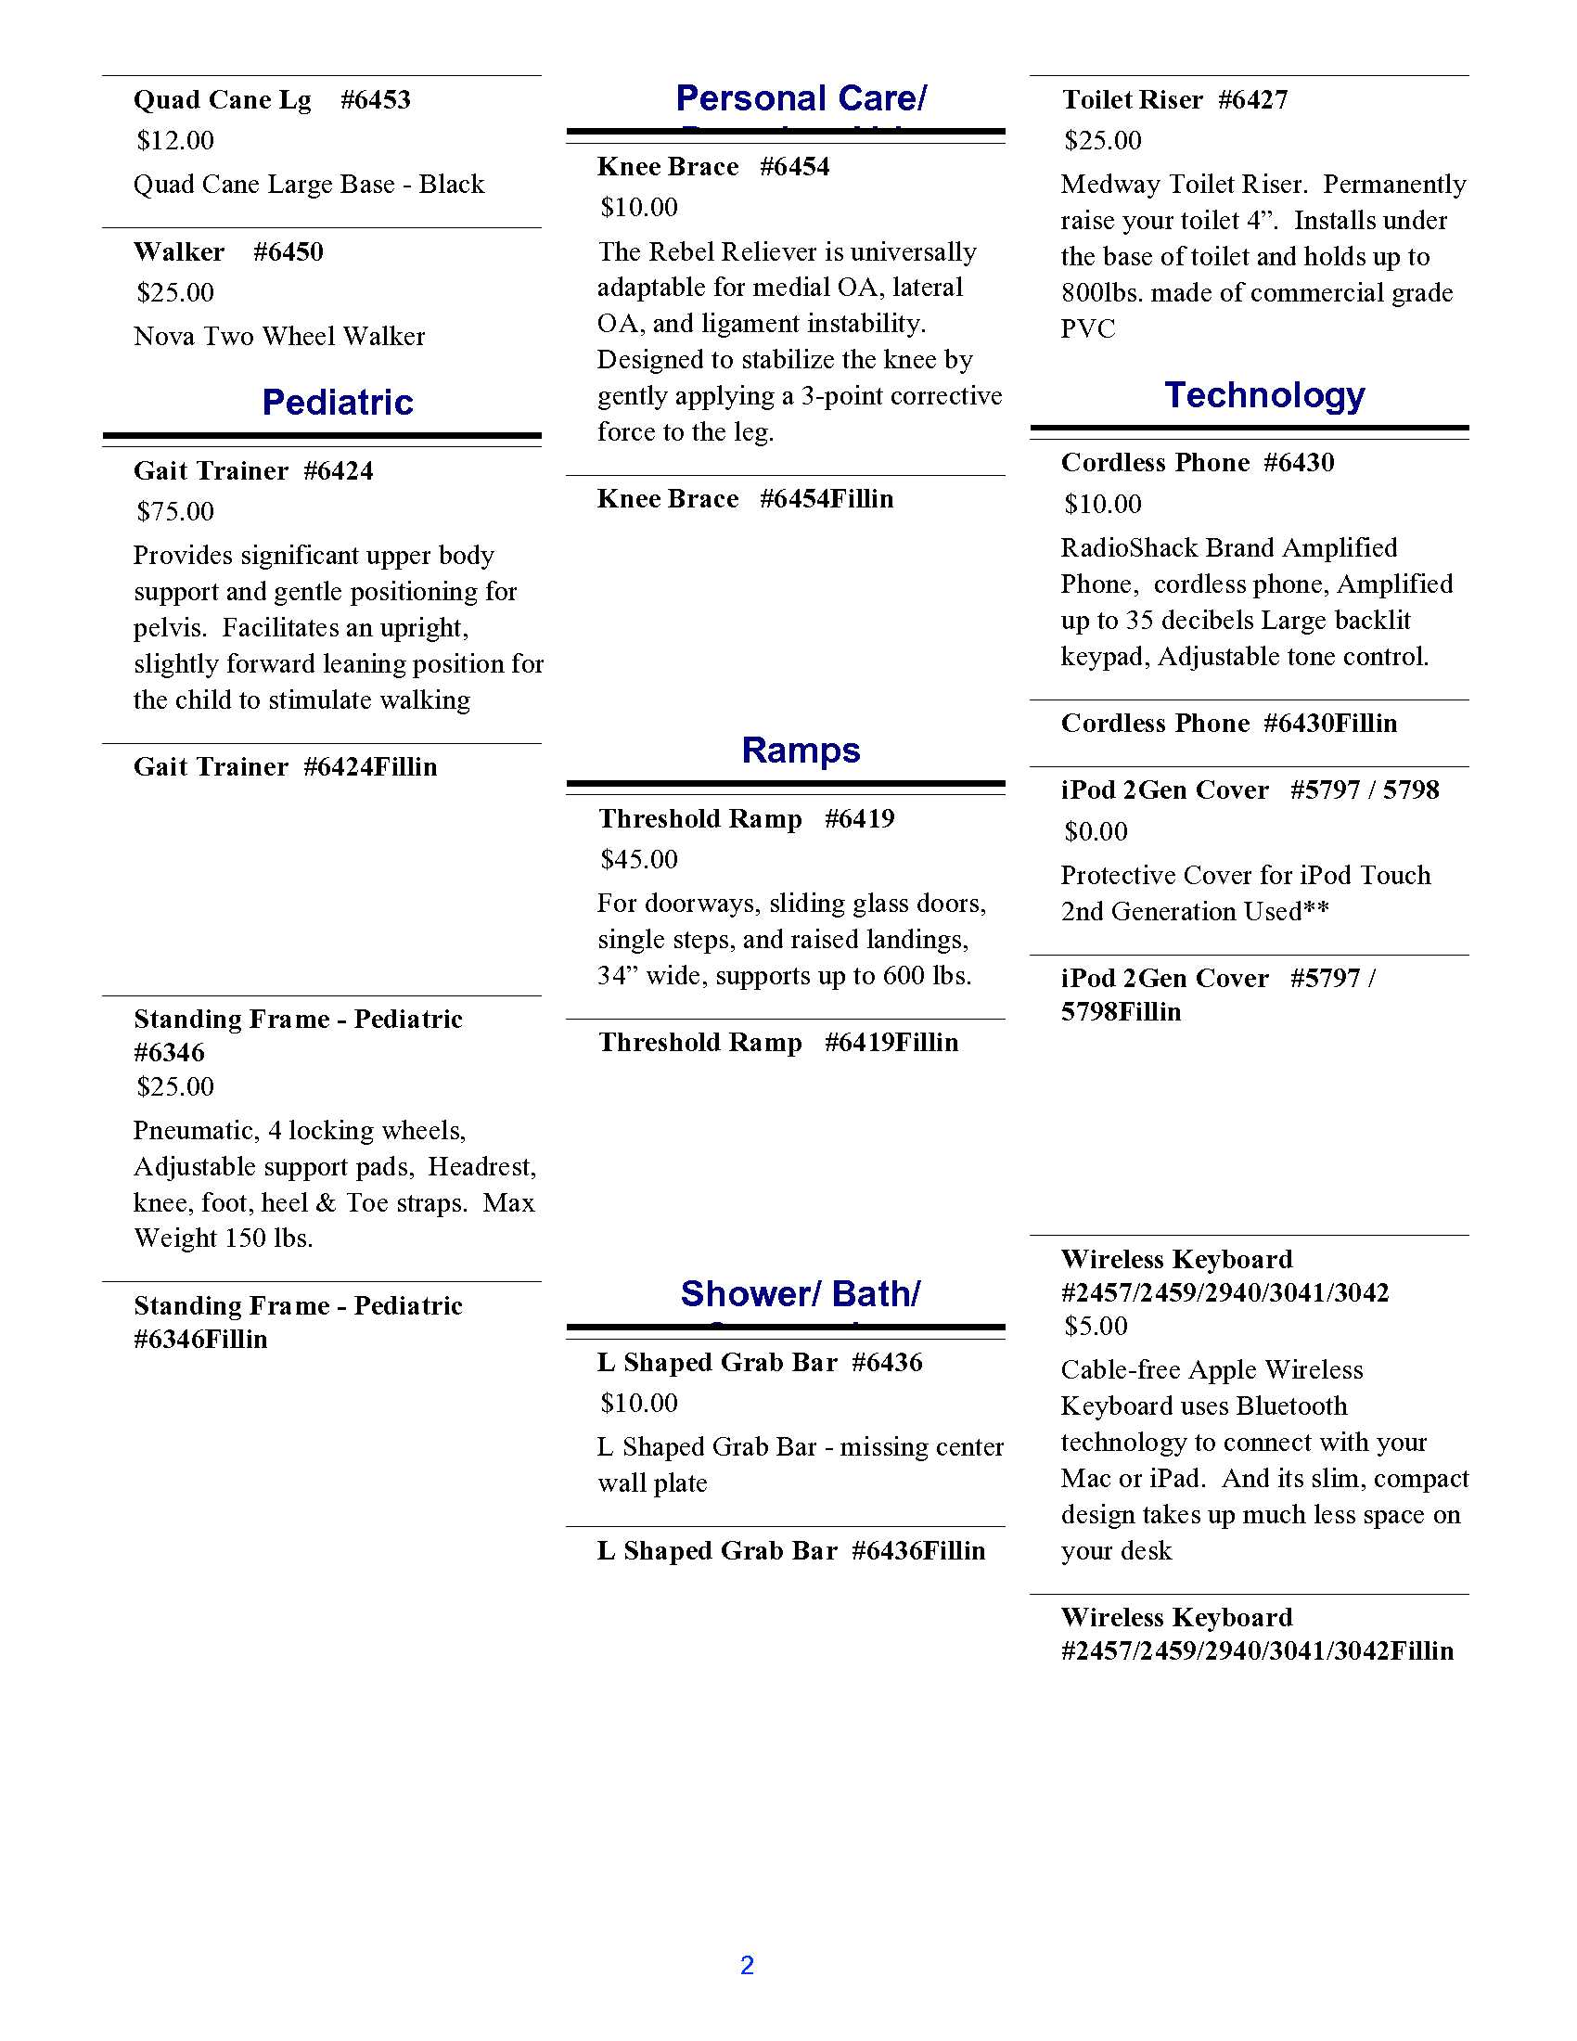

**Wireless Keyboard**

**Knee Brace**

**iPod Cover**

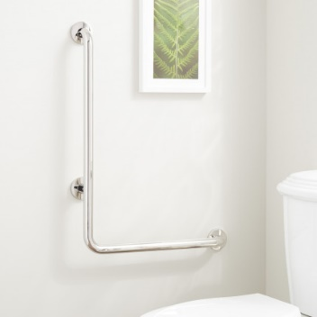

**Grab Bar**

**Threshold Ramp**

**Standing Frame**

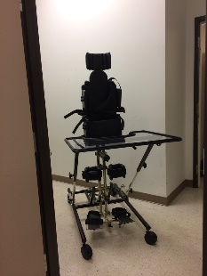

**Standing Frame**

**Consumer Listings**

## Telescopes

Head worn telescopes are task specific, and designed for use with or without your existing eyewear. For example, if you experience eye fatigue while watching the evening news, you may wish to explore a distance telescope, such as the MaxTV; which provides 2.1x magnification. For close-up tasks or hobbies, perhaps the MaxDetail will provide more clarity. Both of these telescopes are available in a clip style that easily attaches to your existing eyewear, or as “stand alone” glasses.

For distance spot viewing tasks, including reading signs in a grocery store, exploring artwork at your local museum or attending a sporting event, consider a single hand use telescope, such as the Microlux, which as an added bonus includes the ability to use it in reverse so that it acts as a field expander, proving ideal for individuals with restricted visual fields.

With so many low vision aid options selecting the right device can seem daunting. That’s why the Specialists at Access Technologies, Inc. (ATI), provide FREE educational demonstrations of over 2,000 assistive technologies, including magnifiers and eyewear. Call our office at 503-361-1201 and schedule time to have a Specialist walk you through a hands-on (eye-on) demonstration of easy to use low vision solutions.

## The Future of Low Vision Aids

The Assistive Technology Industry Association (ATIA) held its annual exhibit in Orlando recently, and exhibitors from all over the AT industry were on hand to support existing products and demonstrate the latest technology that they have to offer. As February is recognized as Low Vision Month, here are a few of the newest devices for people with vision impairments.

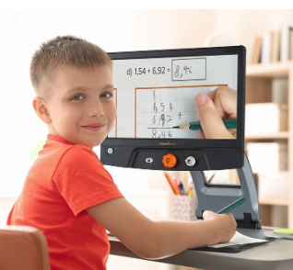First up is the Reveal 16 from HumanWare, an HD magnifier that has a 16-inch screen and up to 45x digital magnification and programmable contrast colors. The camera adjusts for distance viewing, as well. This device is foldable and weighs 13 pounds, making it easy for individuals to travel to classes and conferences. According to representatives present at the ATIA Conference, the next generation of devices will have Android OS installed on them to allow users to access their emails and other media through one integrated device!

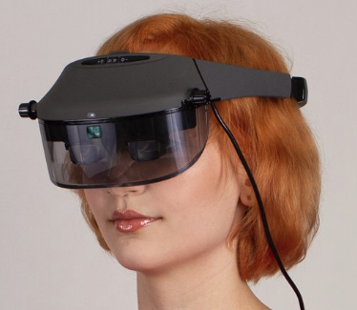Many exhibitors at the ATIA Conference were demonstrating wearable low vision devices. One great example are electronic glasses. Electronic glasses are lightweight and one size fits most for hands-free magnification. Acesight, the makers of one popular model at the conference, boast that their glasses have a 45-degree field of view without obstruction of peripheral vision. The glasses are capable of up to 15x magnification, and do not flicker when using a computer or watching TV. It is possible with these glasses to capture a still image to zoom in on, and a variety of color contrasts are available.

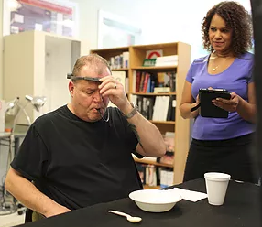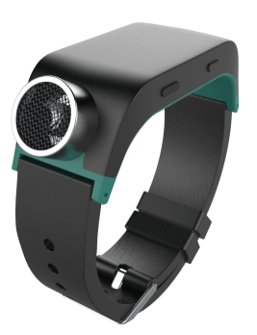The third futuristic piece of technology on display at the ATIA Conference was the BrainPort Vision Pro, another wearable device that sends electronic signals to the user’s tongue to add visual perception for those with profound vision loss. The device consists of a headband, grayscale video camera, a rechargeable battery, and a tongue array that has 394 electrodes! The camera identifies white pixels and presents those on the tongue array as a strong stimulation, while gray pixels deliver a medium stimulation and black pixel deliver no stimulation. The stimulations are said to feel like sparkling water “fizz” and the strength can be adjusted up or down by the user as needed. This device is available by prescription only, and users will need to receive 10 hours of training over three days in order to get the full benefits of use.

Also on display at the ATIA Conference was the Sunu Band, a bracelet that uses echolocation and haptic feedback to guide users around obstacles. This device is designed to work alongside using a white cane or guide dog to increase awareness of surroundings for people with low vision or total blindness. When paired with a smartphone, the Sunu Band can pair with a GPS navigation app to allow users to explore unfamiliar places with increased confidence and fewer accidents and injuries.

With devices like these in development and in production, the future for people with low vision is looking bright!



ATI's contact information
Office Location is 2225 Lancaster Drive NE Salem OR 97305
Telephone 503-361-1201

