Tech It Easy

May 2018 Edition
Editor: Laurie Brooks
Access Technologies, Inc.
Inside this Issue:
Accessible Walking Trails | 1
AT for Walking | 2
AT for Birding | 2
ATM — MarketPlace | 3-7
Bargain Basement | 8-9
Ask REMI(Geocaching) | 10
AT for Fishing | 11
iCanConnect-Oregon | 12

Engage at Every Age

May is time to recognize and celebrate Older American’s Month! This year’s theme, Engage at Every Age, emphasizes that you are never too old (or young) to take part in activities designed to enrich your physical, mental and emotional well-being. This edition of Tech It Easy will explore a variety of assistive technologies designed to help you – engage in Oregon’s great outdoor activities.

Walking/Hiking
Whether you are taking a stroll around your neighborhood or a leisurely hike along a quiet nature trail, keep an eye out for uneven sidewalks, trip hazards and loose gravel.
Some popular scenic walking trails around Oregon include:
Riverfront Park: located in Salem with walking trails around the park and along the Willamette River. This 23-acre park is connected to Minto-Brown Island Park by the Peter Courtney Minto Island Bicycle and Pedestrian Bridge and to Wallace Marine Park by the Union Street Railroad Bridge – providing more than 20 miles of walking trails.
Baskett Slough Morgan Lake: offers a 5.1 mile loop trail near Dallas that features a lake and wildlife viewing. Baskett Slough has two trail heads. The main trail head is on Coville Road, and Morgan Lake Trail is located on Smithfield road, which is open seasonally.
Middle Fork Willamette Path from Clearwater Park: offers a 7.7 mile out and back trail located near Springfield. This paved trail along the Willamette River offers close-up views of wildlife and wildflowers as well as views of Mount Pisgah.

South Jetty Trail: offers an accessible 1.9-mile out and back trail located near South Beach that features a river.
Whether hiking around your neighborhood, or along one of these scenic trails, for individuals who are unsteady on their feet or tire easily, there are a wide range of mobility aids they may wish to consider; including, canes, standard walkers, rollators and Duets.
When using a standard two-wheel walker, remember to check the walker glides for uneven or excessive wear and replace them before they become so worn that the walker legs are touching the ground. ATI has a number of individuals who walk the soles right off their heavy-duty walker glides monthly. Now that’s some serious community engagement!
A rollator is a 4-wheel walker with handbrakes and a seat that provides added stability, and the seat allows for a nice resting place. If your walking partner tires out a little before you do, perhaps a Duet is more appropriate. The Duet combines the features of a rollator and transport chair in one unit.
Mobility aids and walker glides are available through ATI’s MarketPlace, and if you are unsure which mobility aid is right for you, check our short term Device Loan Library.

Birding
Bird watching is another great way to engage in Oregon’s nature. According to the Audubon Society, the main gear for this activity includes a pair of binoculars. Birders note when selecting binoculars make sure to consider a model that allows you to see subtle features in poor light and sharp enough to easily view fine detail. Also, the binoculars should focus quickly and provide a wide enough field of view to locate birds rapidly and follow them in flight.
Individuals who find it difficult to steady binoculars, may wish to consider image stabilized binoculars. With the simple push of a button on top of the binocular, the hand-held picture stabilizes as if it were mounted on a tripod. If you have not tried image stabilized binoculars, borrow a pair from ATI’s Device Lending Library and engage with the other 47 million birders in the United States.
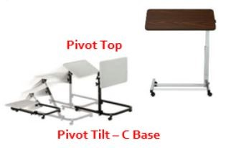
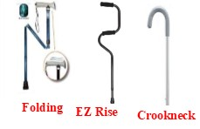
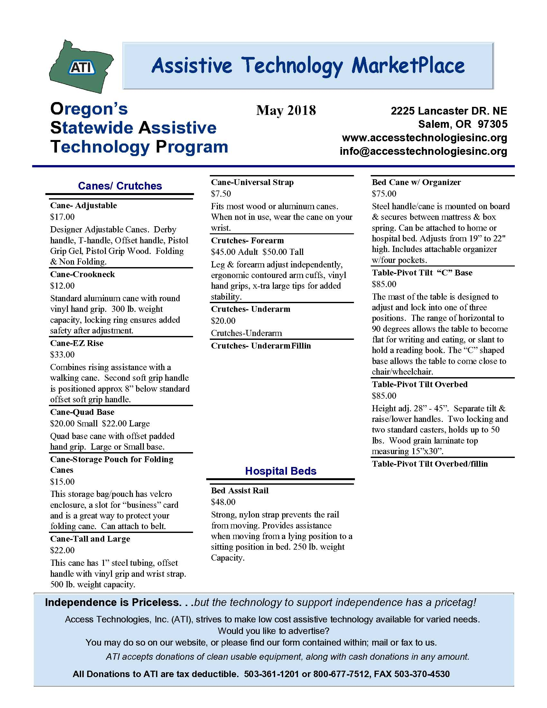

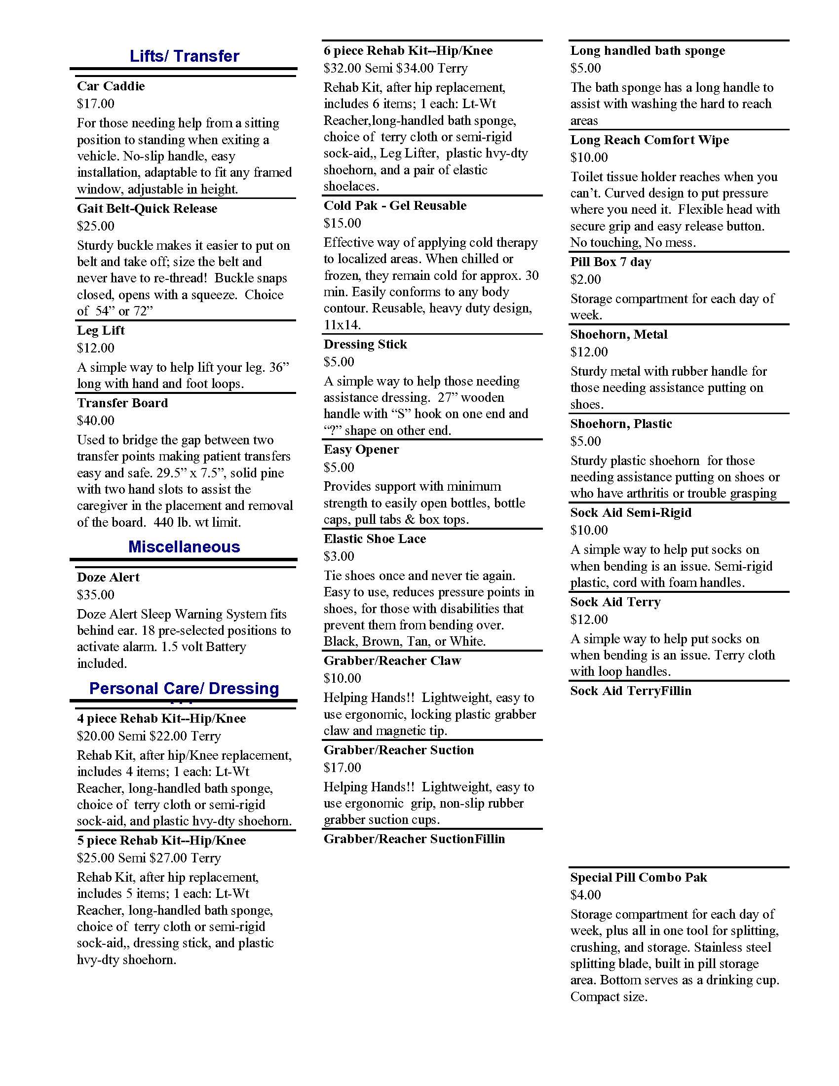
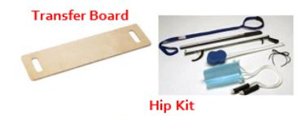

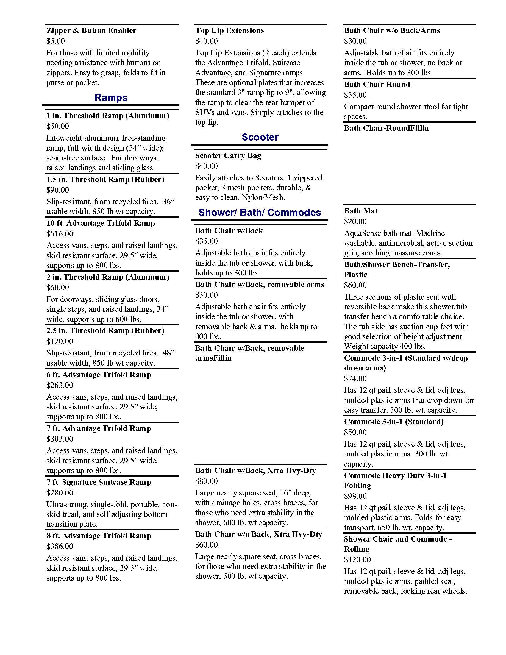
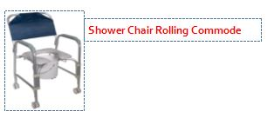
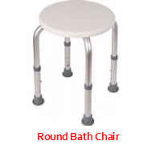

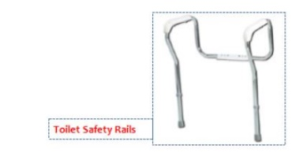
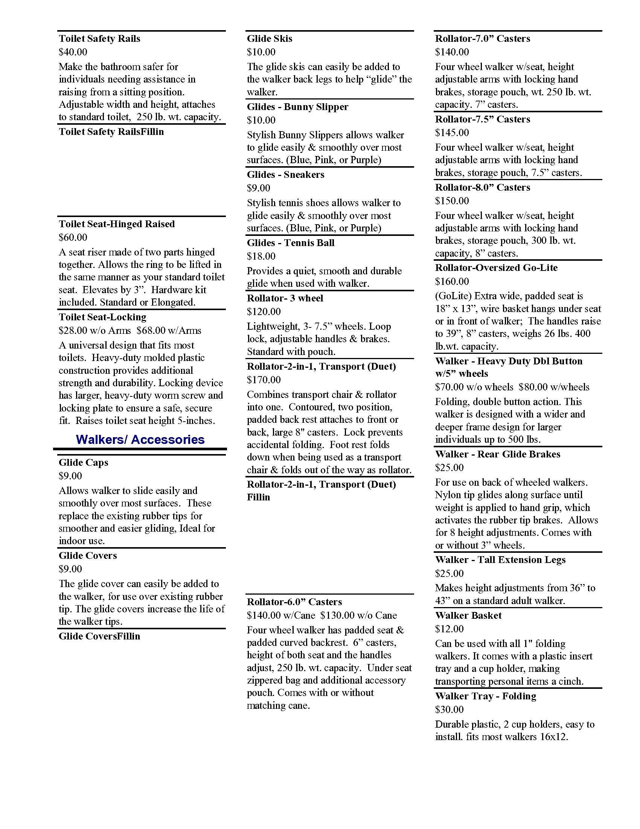
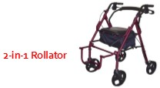
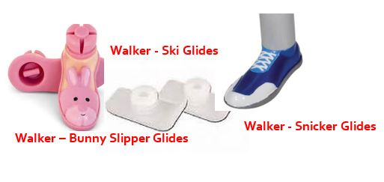

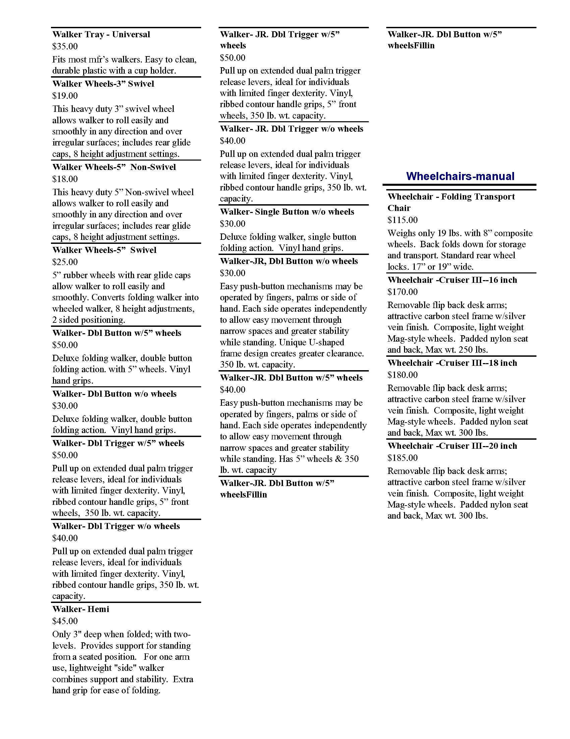
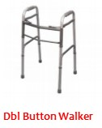
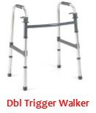
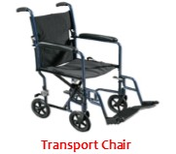
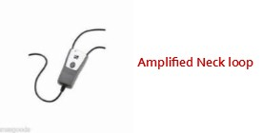
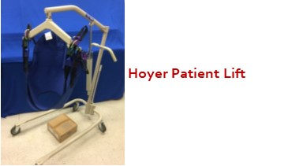
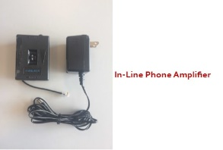
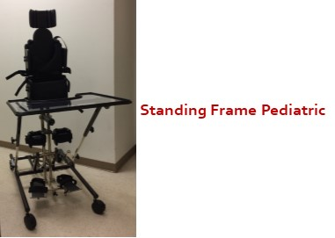
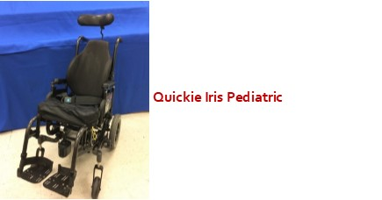
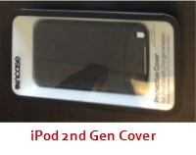

Ask REMI!
Dear Remi,
The other day I overheard some people talking about geocaching. Can you please tell me what a cache is, and how one goes about catching it.~ MW
Thank you for your question MW. Geocaching is an outdoor activity that will get you moving – sometimes both body and mind. If you like treasure hunting, engage in the craze of geocaching!
Caches are hidden all over the world by fellow geocachers who put together a hodgepodge of trinkets, along with a logbook and pen or pencil. This hoard is then stuffed into a weatherproof container – some no bigger than a film canister, and hidden under a rock, behind a tree or maybe even in a more urban setting. Then the geographical coordinates of the container are posted on one of several Web sites for fellow geocachers to follow. One of the first and still most popular sites is geocaching.com, where you can find updates to the game, photos and stories shared by fellow geocachers.
Download the official geocaching app to your smartphone to view a map of geocaches in your area. Then navigate to a cache that is hidden near you. Once you find a cache, open the container and sign the logbook. You may discover some trade or swag items (small toys, keychains, trinkets) inside the geocache. The general rule of thumb is if you take something, leave something of equal or greater value. Then, place the container back exactly how you found it and share your experience online with the rest of the geocaching community. What a fun activity to enjoy with friends and grandkids alike!
Depending upon your vision, you might find it challenging to locate some geocaches, because different eye diseases affect the way light is perceived. Therefore, you may find contrast enhancing glasses, which are available in five different lens tints, may help you locate geocaches more easily. If you have not tried contrast enhancing eyewear, schedule time with an ATI Specialist to locate a lens tint that best accommodates your vision.

Fishing
Fishing is another great outdoor activity to engage in. There are over 100 areas in Oregon designated as places for anglers with disabilities to fish comfortably and safely. Some popular sites include:
Blue Lake: located 3 miles west of Troutdale, offers rainbow trout, largemouth bass, brown bullhead, black crappie, and bluegill. Amenities include an accessible fishing dock, wetlands observation deck, trail loop and a ramp for small boats.
Detroit Lake: located in the Cascade Mountains, is a 400-foot-deep lake is especially good for anglers looking for rainbow trout. Amenities include an accessible fishing dock.
Lake Lytle: located ½ mile north of Rockaway Beach on Highway 101, offers rainbow trout, largemouth bass, and yellow perch. Amenities include a boat ramp off 12th Street on the north end of the lake as well as an accessible area.
North Fork Reservoir: located behind the North Fork Dam, approximately 5.2 miles east of Estacada, offers rainbow trout, salmon and steelhead. Amenities include an ADA accessible fishing pier.
ATI’s Device Lending Library has over 2,000 devices – including the following aids to assist with fishing:
Elec-Tra-Mate Fishing Reels: Designed for the angler who experiences difficulties reeling in their catch. These switch adapted, battery powered reels are ideal for heavy fresh water or light saltwater fishing.
Rod Holders:
For the angler who needs an “extra hand” holding their rod our library includes the Anglers Aid, Turboset and Van’s EZ Cast Rod Holder.

Knot-TY-All:
Designed to assist individuals with arthritis with tasks such as threading hooks, tying knots and cutting fishing line.

And if you are considering an overnight fishing trip, our short term Lending Library even has a wheelchair accessible tent!

